Supplementary Material for
Assessing the Climate Impacts of the Observed Atlantic Multidecadal Variability using the GFDL CM2.1 and NCAR CESM1 Global Coupled Models
Yohan Ruprich-Robert, Rym Msadek, Frederic Castruccio, Stephen Yeager, Thomas Delworth, Gokhan Danabasoglu

Importance of the simulation drift on the AMV impacts
a) Interpretation of the drift
All results discussed in the main study are based on 10-year long simulations. We chose to not use longer simulations due to the presence of a drift over the North Atlantic subpolar gyre (SPG) region in CM2.1 (Figs. 4a and S1), which is introduced by our experimental set-up. We found two origins for this drift. First, restoring the sea surface temperature (SST) over the SPG region through warm anomalies tends to stabilize the ocean column, which leads to a decrease of the deep ocean convection, eventually favoring the formation of negative density anomalies over the entire ocean column. The weakened SPG density then leads to both an AMOC slowdown and a decrease of the SPG strength, which are all together responsible for a decline of the northward oceanic heat transport. Similarly, cold anomalies imposed over the SPG leads to an acceleration of the northward oceanic heat transport. This oceanic drift is detectable but weak in the CESM1 experiments whereas in CM2.1 it is strong enough to counteract the imposed temperature anomalies over the western SPG. It leads to an anomaly of opposite sign around 30°W in winter during the last years of the simulation (as seen by the crossing of the AMV+ and AMV- lines around year 7-8 on Fig. S1a).
Moreover, by extending the CM2.1 simulations up to 21 years we found that both AMV+ and AMV- simulations exhibit a decreasing temperature trend. This indicates that another drift independent of the one created by the imposed temperature anomaly is introduced by our experimental protocol. Indeed, even when the model SSTs are restored only to their climatology (hereafter CTL), a similar cooling drift can be seen over the western SPG (cf. black lines on Fig. S1).
One possibility to explain the cause of this second drift – present as well in the CTL simulation – comes from the fact that when we restore temperature and not salinity, we create a system with stronger positive feedbacks. For example, a positive AMOC anomaly brings warmer and saltier water northward. The temperature anomaly is damped by the restoring term, leaving primarily the salinity anomaly and creating positive density anomaly. This tends to amplify the initial AMOC anomaly (cf. salinity feedback; e.g. Born and Livermann 2007), whereas the temperature anomaly would have been a negative feedback (but has now been damped away by the restoring term; cf. Fig. S2). Thus, the system is more prone to positive feedbacks. Similarly, a negative AMOC anomaly generates cold, fresh anomalies - but the cold anomaly is damped, leaving only the fresh anomaly that further weakens the AMOC. This should then lead to stronger positive feedbacks in both directions. So, why does the AMOC weaken? A positive AMOC anomaly is linked to enhanced convection, which involves a deeper layer of the ocean. This deep mixed layer tends to moderate the effect of the SST restoring. The negative temperature feedback – even if reduced – can then still partly counteract the positive salinity feedback. In contrast, a negative AMOC creates a fresh cap that tends to isolate a thin upper layer from the interior ocean. The SST restoring is then more efficient and the positive salinity feedback may amplify more efficiently the negative AMOC anomalies..
Our hypothesis is consistent with the time evolution of the AMOC distribution of the CTL ensemble member simulation (Fig. S3-left column). Initially the AMOC distribution from CTL matches the one from a long coupled simulation performed without SST restoring (hereafter FREE_CPL). After 11 years of integration, CTL shows a more scattered AMOC distribution than FREE_CPL, as revealed by the tilting of the CTL cumulative PDF (red line), indicating a more unstable system. After 21 years of integration, the CTL spread is about the same as at year 11 but the AMOC distribution is shifted toward a weaker state with a median value about 2.5 Sv weaker than that of FREE_CPL.
b) Correction of the drift
Following our hypothesis, to correct this model drift we performed control experiments in which both the SST and the sea surface salinity (SSS) are restored to their climatology in order to avoid the positive salinity feedback. With this corrected protocol we performed 3 different control experiments using a restoring timescale of 1 day (not shown), 5 days (CM2.1_SSSrest_5days), and 15 days (CM2.1_SSSrest_15days). Results from these experiments prove that the SSS restoring decreases the AMOC drift (cf. Fig. S3). It also shows that the longer the restoring timescale, the weaker the AMOC drift. This was expected as the longer the restoring timescale, the closer the model is to a free coupled configuration. Yet, the SSS restoring appears to introduce a stronger temperature drift over the Western SPG during the first 5 years of the SSS-restored experiment compared to non-SSS-restored experiment (Fig. S4). Interestingly, after year 10, no strong drift is present in the CM2.1_SSSrest_5days and CM2.1_SSSrest_15days experiments, suggesting that those simulations have reached a new equilibrium. Indeed, by continuing the CM2.1_SSSrest_15days control simulation for 10 more years, we see that the Western SPG temperature is remarkably stable (cf. black line on Fig. S5a).
c) Drift-corrected experiments with CM2.1
Given that the CM2.1_SSSrest_15days control experiment shows a stable Western SPG temperature and the smallest AMOC drift, we performed new Full_AMV experiments using this configuration. 100 members for both Full_AMV+ and Full_AMV- simulations were initialized from the first day of year 21 for the 100 members of the CM2.1_SSSrest_15days control simulation. The North Atlantic SST in these new experiments are restored to anomalies corresponding to +/-1.5 standard deviation of the observed AMV pattern (Fig. 1b) using a 15 days restoring timescale. Besides, SSS are restored to values that counterbalance the surface density anomalies generated by the SST restoring. We changed the amplitude of the anomalies toward which the SST are restored to, as the longer restoring timescale in this experiment leads to a weaker constrain on the SST. This leads to imposed SST anomalies effectively weaker than those one we want to introduce due to high frequency processes that tend to dissipate the imposed sea surface heat anomalies.
As for the control simulation, Figure S5a shows that the SPG temperature of the new CM2.1 Full_AMV experiments are stable during the 10 years of the integration and they present values similar to the CESM1 ones (Fig. S1b). As expected from Figure S5a, we see that the DJFM surface air temperature (T2m) is better constrained over the western SPG region in the new AMV experiments performed with CM2.1 (compare Fig. S5d and Fig. 4a). We note also that significant negative sea level pressure and positive precipitation anomalies are now present over this region, showing that the AMV impacts were locally under estimated (compare Fig. S5e,f and Fig. 4c,e). However, overall results are very similar in terms of T2m, sea level pressure, and precipitation at global scale. We further verify whether the drift has polluted the results discussed in the article. We find that the strongest impact of the drift concerns the atmospheric response over the North Atlantic – Europe region. The drift-corrected CM2.1 experiments tend to show a response that projects mainly on NAO- (Fig. S5b) whereas the non-corrected CM2.1 experiments show a response that projects on both NAO- and EAP- (Fig. 5a). Yet, we highlight that in both cases the atmospheric signal to noise ratio is very weak (smaller than 5 % of the decadal variance). We then do not exclude that these differences are possibly coming from noise.
Given the small differences between the drift corrected and non-corrected Full_AMV experiments performed with CM2.1, the authors believe that the results discussed in the main paper are overall robust. Therefore, we did not perform new set of simulations for the SPG_AMV, the Trop_AMV, the Damped_Global_AMV, the Damped_TropPac_AMV, and the XTrop_AMV experiments with CM2.1.

References:

Gill, A. E., 1980: Some simple solutions for heat-induced tropical circulation. Q. J. R. Meteorol. Soc., 106, 447–462, doi:10.1002/qj.49710644905. http://doi.wiley.com/10.1002/qj.49710644905.
Levermann, a., and A. Born, 2007: Bistability of the Atlantic subpolar gyre in a coarse-resolution climate model. Geophys. Res. Lett., 34, L24605, doi:10.1029/2007GL031732. http://doi.wiley.com/10.1029/2007GL031732 (Accessed December 16, 2013).
Morice, C.P., Kennedy, J.J., Rayner, N.A. and Jones, P.D., 2012: Quantifying uncertainties in global and regional temperature change using an ensemble of observational estimates: the HadCRUT4 dataset. Journal of Geophysical Research, 117, D08101, doi:10.1029/2011JD017187
Figure S1:
(a) Ensemble mean time series of the annual ocean temperature spatially averaged over the Western SPG (cf. limits on Fig. S5a) and depth averaged over the first 200 meters, from the AMV+ (red), AMV- (blue), and CTL (black) simulations of CM2.1. (b) Same as a but for CESM1.
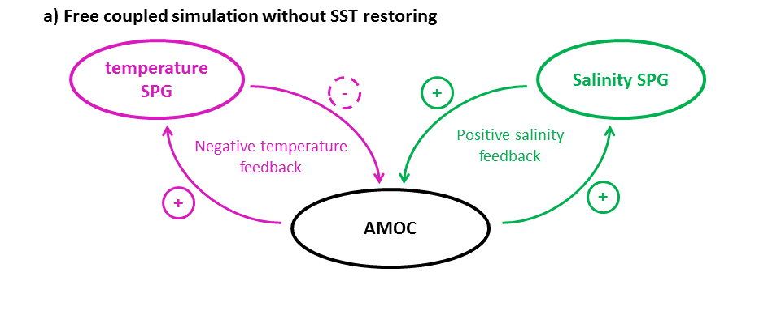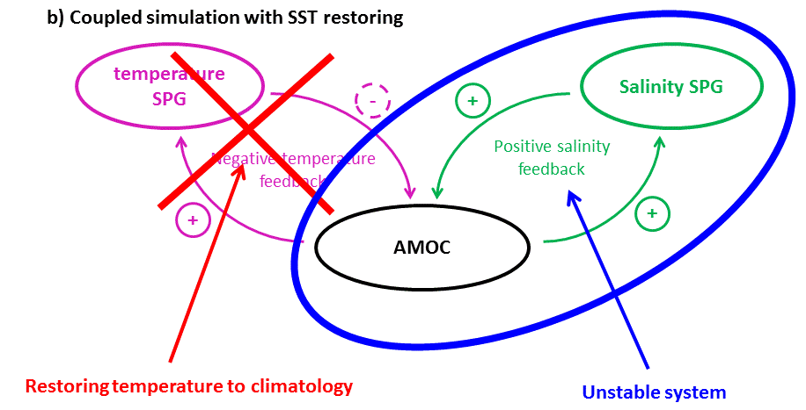
Figure S2:
Schematic of the AMOC-temperature and AMOC-salinity feedback (a) without temperature restoring and (b) with temperature restoring.

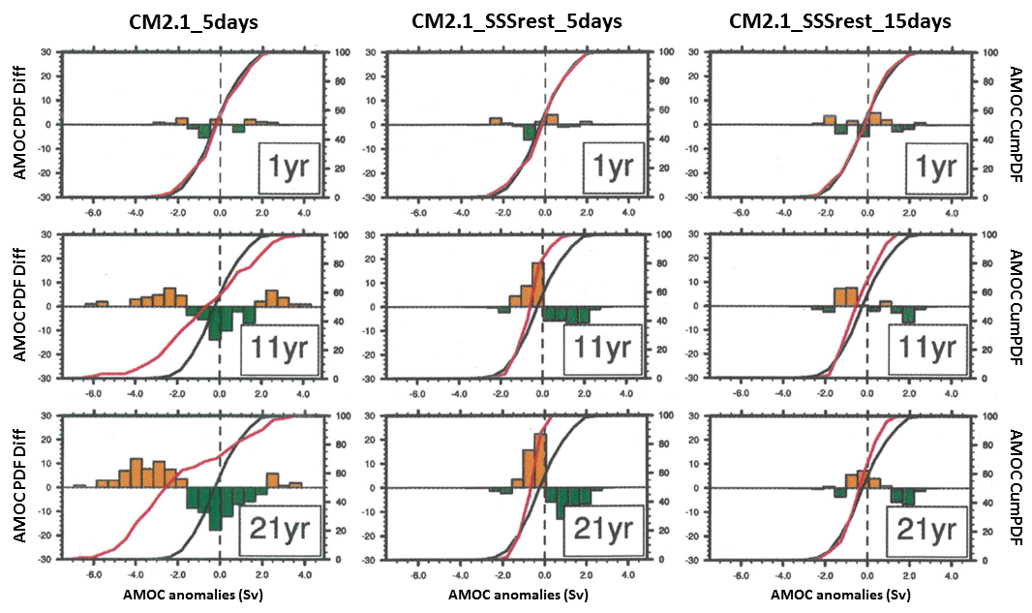
Figure S3:
AMOC index distribution of the CM2.1 control experiments performed with (left) a 5-day restoring of the SST, (middle) a 5-day restoring of the SST and the SSS, (right) a 15-day restoring of the SST and the SSS at lead time (top row) 1 year, (second row) 11 years, and (bottom row) 21 years. The black line (common to all panel) represents the AMOC index cumulative Probability Density Function (PDF; cf. right axes) from a long control simulation of CM2.1 performed without any restoring. The red lines represent the AMOC index cumulative PDF of the control experiments. The color bars represent the difference bin by bin between the free simulation and the control experiment PDFs (cf. left axes). The AMOC index (in Sverdrup) corresponds to the spatial average of the annual AMOC between 900m-1400m and 40ºN-45ºN, which encompassed the climatological maximum of the AMOC.
Figure S4:
Same as Fig. S1a but for the CM2.1 control simulation performed with a 5-day restoring SST (black line), a 5-day restoring SST and SSS (dashed dark gray line), and a 15-day restoring SST and SSS (light gray line).

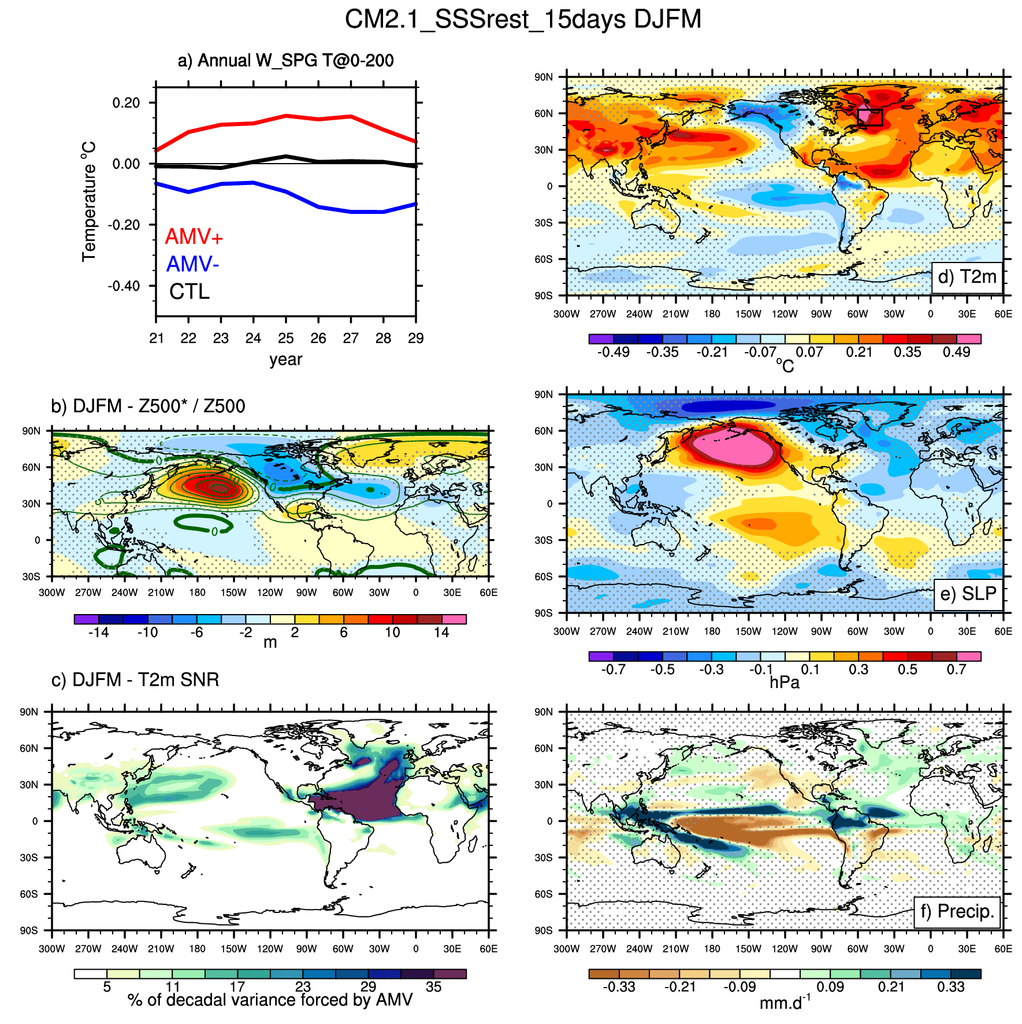
Figure S5:
(a) same as Fig. S1a but for the CM2.1_SSSrest_15days AMV experiments. (b) same as Figure 6a but for the CM2.1_SSSrest_15days AMV experiments. (d) same as Fig. 15a but for CM2.1_SSSrest_15days AMV experiments. (d,e,f) same as Fig. 4a,c,e but for the CM2.1_SSSrest_15days AMV experiments.

Figure S6:
Same as Fig. 6 but using the XTrop_AMV experiment instead of the SPG_AMV experiment of CM2.1.

